**HOW TO CREATE A VIRTUAL MACHINE**

PART 1

UNIT 1

*Presented by: HERNAN DAVID ORTIZ JINEZ*

1. **Create an empty virtual machine and configure the following settings:**

• For Windows 10 (64 bits, or 32 if you do not have enough RAM in your physical computer).

• 2GB of RAM memory.

• Boot order (CD and hard drive).

• Two hard drives: one with 50 GB for the operating system and another one with 30 GB empty. Select the type of disk that can dynamically increase.

**Part 1.**

**Virtual Machine creation:**

1. The first step is open the virtual machine that previusly we installed, in this case is Virtual Box, and we have to click on new.

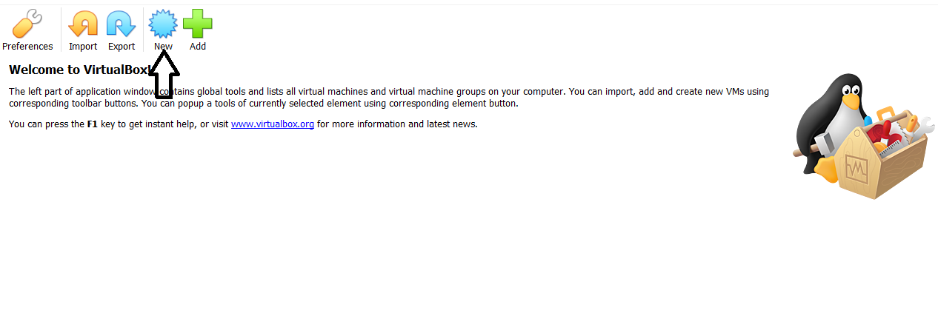

2. Ones you click on the new option, It is going to appear a new window, in this one, we can choose the name, in this case I am going to name it “Windows 10 class”, also we can choose the type “Microsoft Windows”, and the version “Windows 10 (64 bit)”, and click on create.

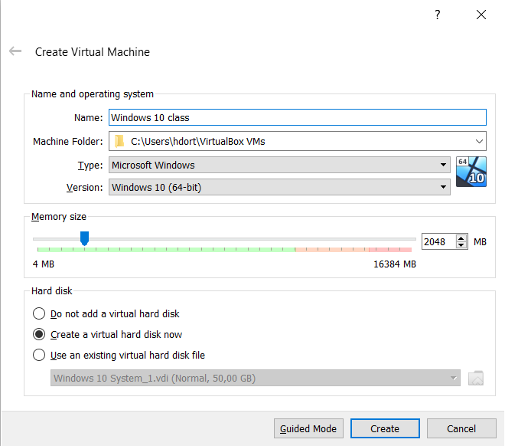

There are trhee options to configure the hard disk:

* Do not add a virtual hard disk
* Create a virtual hard disk now
* Use an existing virtual hard disk file.

In our case, We will select to create a virtual hard disk to boot the type´s machine vdi and storage like a dynamically allocated.

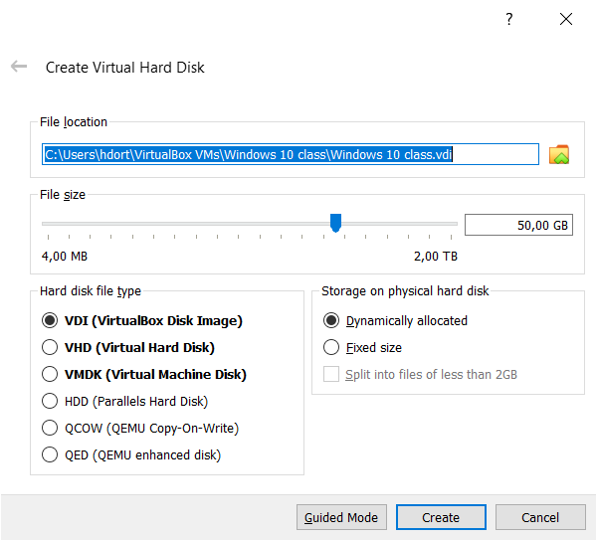

3.The next step is to configure it, to do this we have to click on settings button:

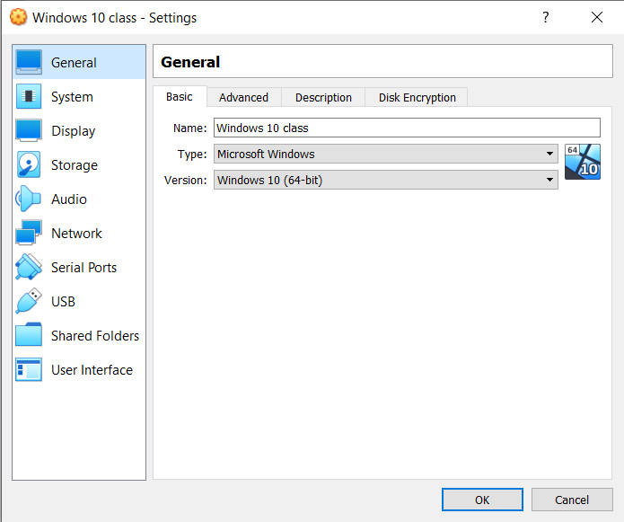

**-Network:** To make the installation easier we unmark the cable conected option.

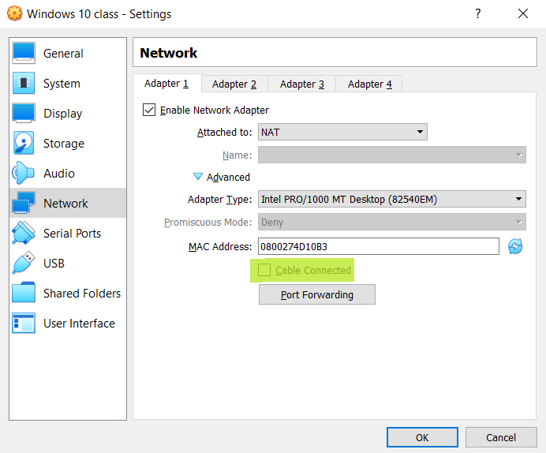

**-System:** We configure the boot order as we can see in the screenshot below, we are going to leave the optical option first and the hard disk later.

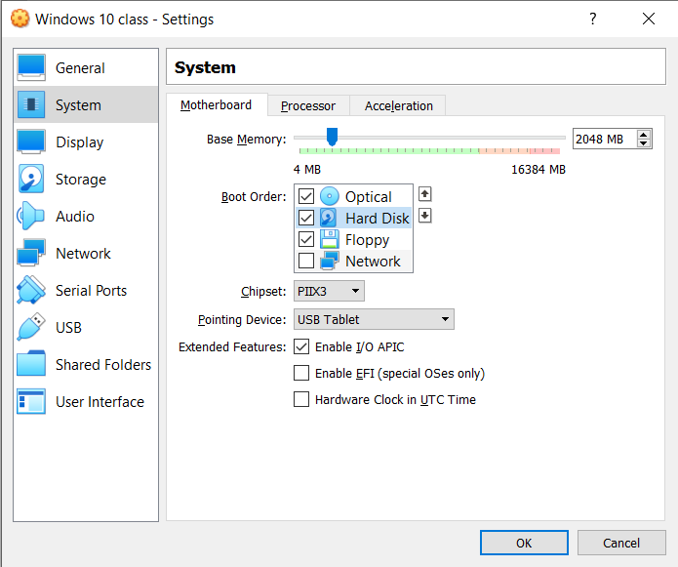

Storage: We are going to choose the a disk file to have a bootable media.

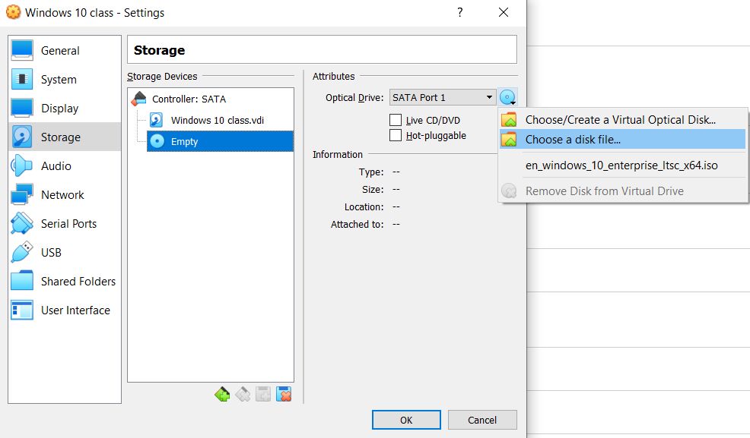

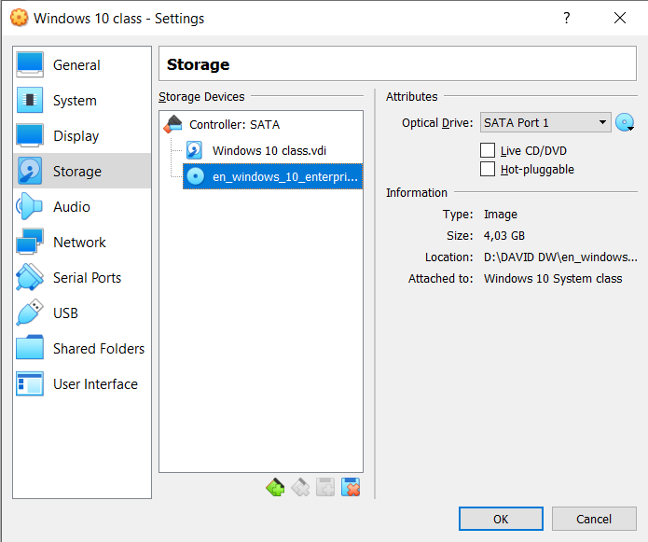

The configuration would be as follows, and we have to select the start option to start the installation.

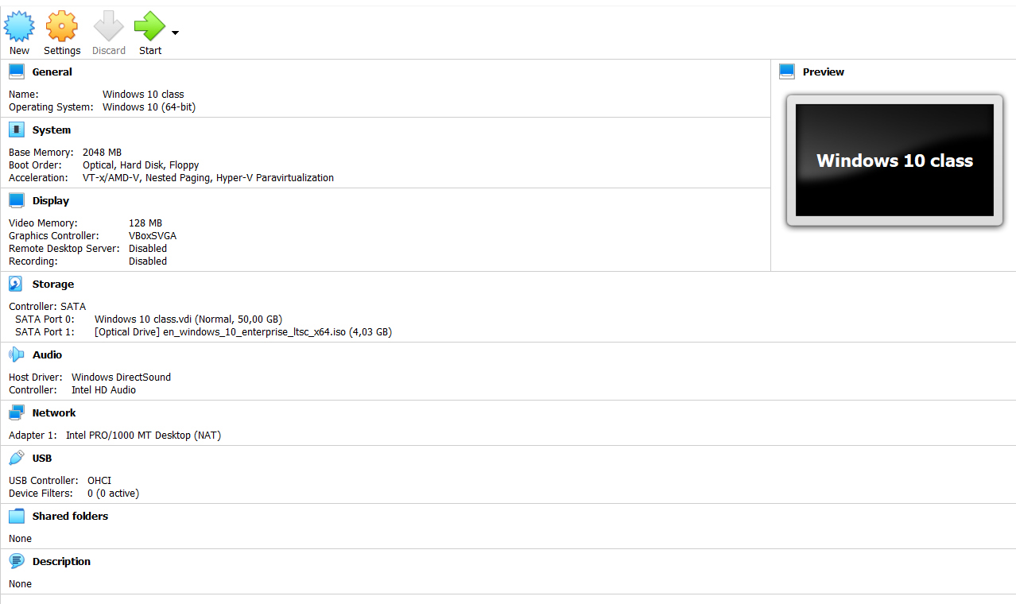

Then we can start the configuration of our Windows.

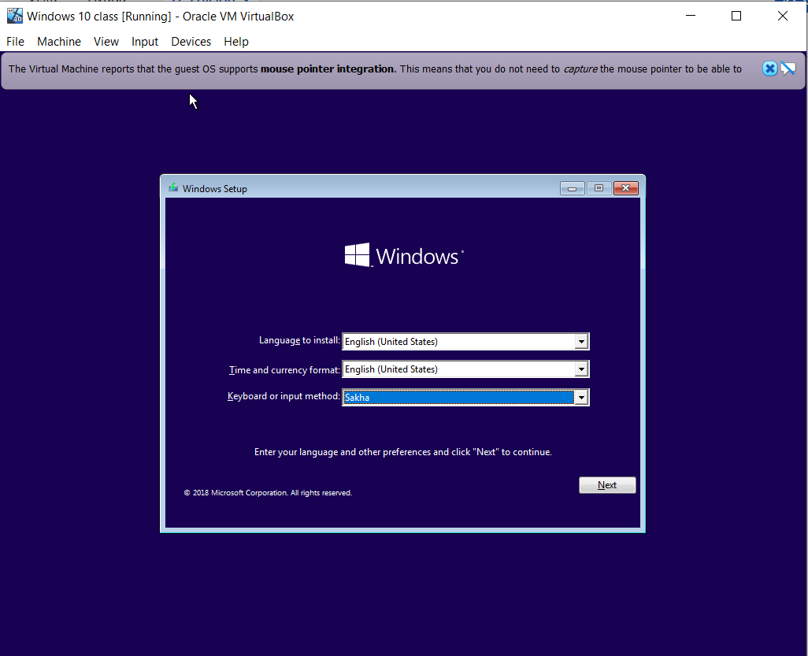

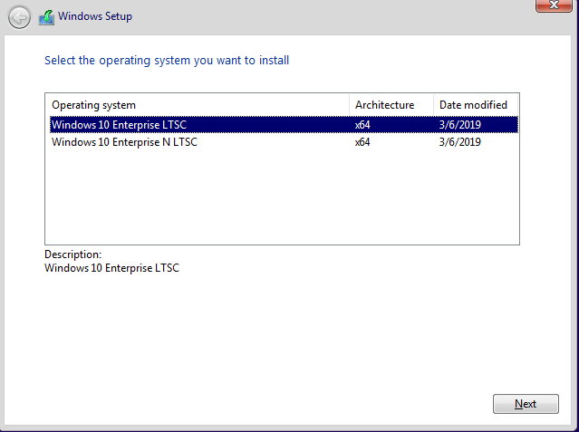

We have to select the Custom option, the other option is if you have another version already installed.

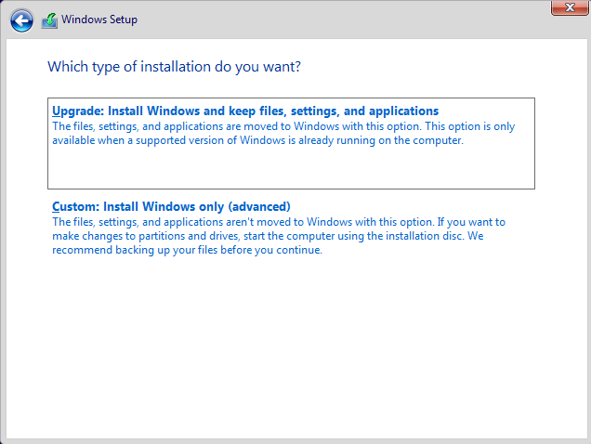

In the next window we can choose the total size and even change it, to create a partition.

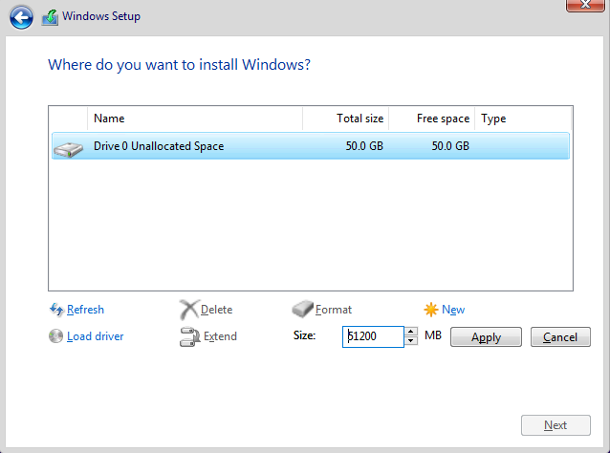

Finally, we have our windows installed.

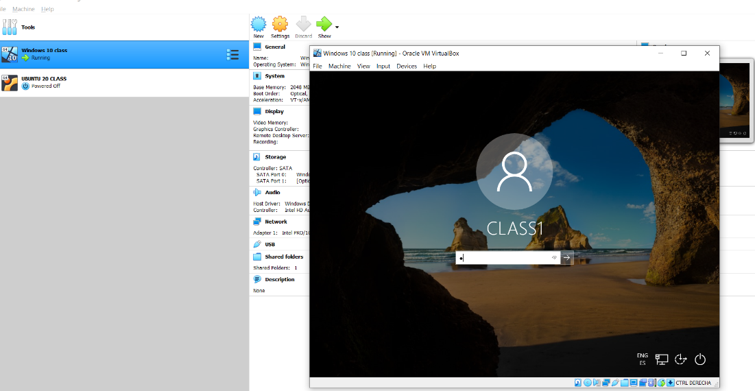

**Part 2.**

**2. Install Windows 10 in the virtual machine from exercise 1. You must add the following settings:**

• USB 3.0 support.

-To do this we have to download the extention from virtualbox web.

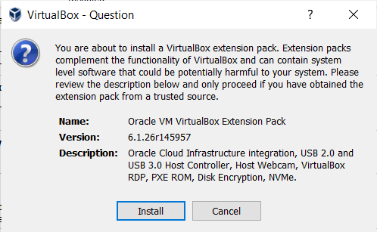

After that we just have to go usb option in setting and select the one we want.

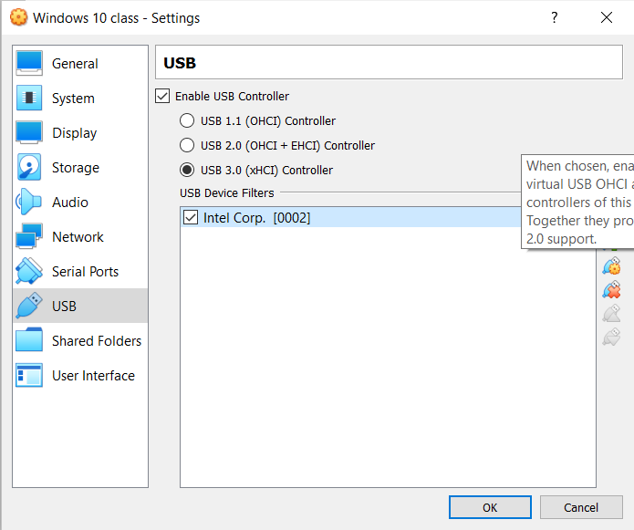

• Shared folders.

We can create a share folder from shared folders within settings.

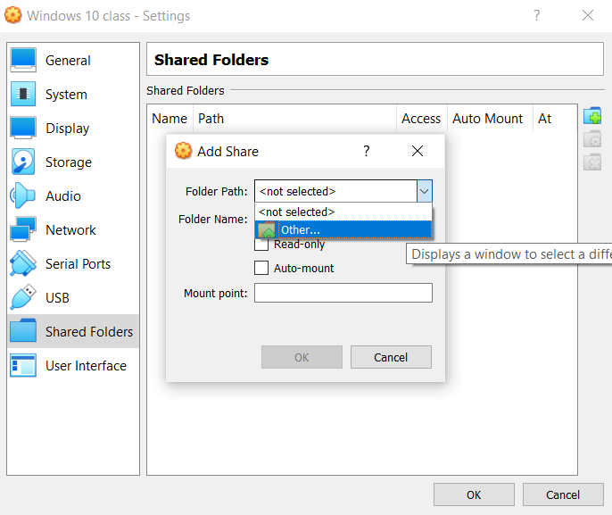

We must to ensure to leave marked the Auto-mount option, this we will allow us to read and make changes in our folder.

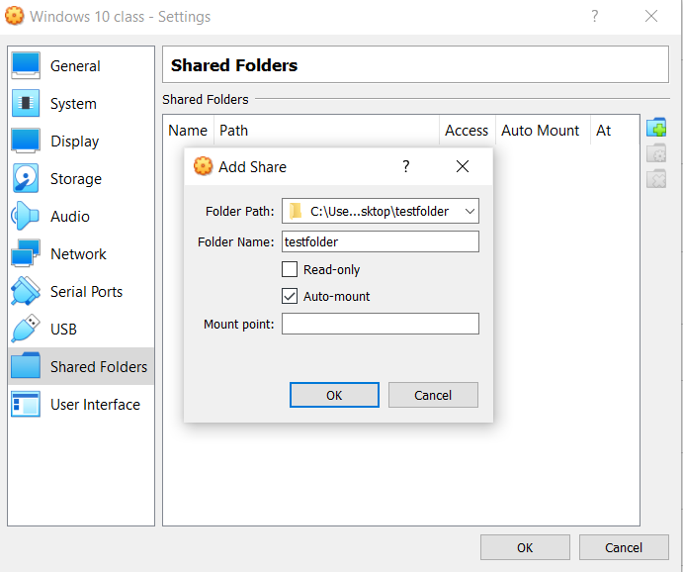

• Internet connection including access to the rest of computers of the network.

In order to do this, we have to go to the Settings and within Network we will select Bridged Adapter option.

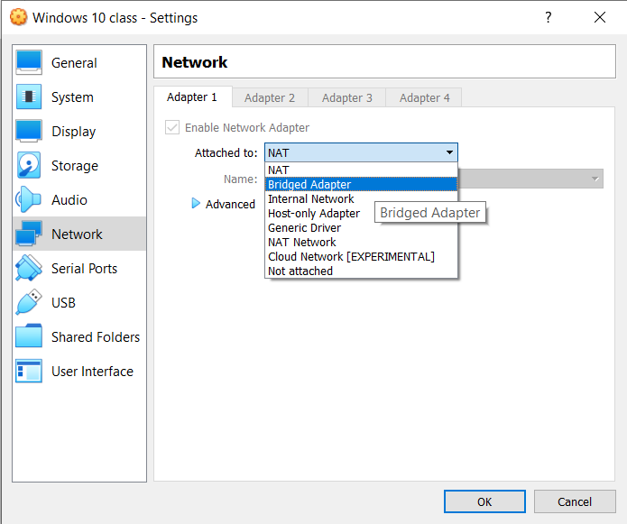

• You will be able to copy and paste from the host to the guest and vice versa.

If we want to make this possible the fist thing we have to do is download the VirtualBox guess drive.

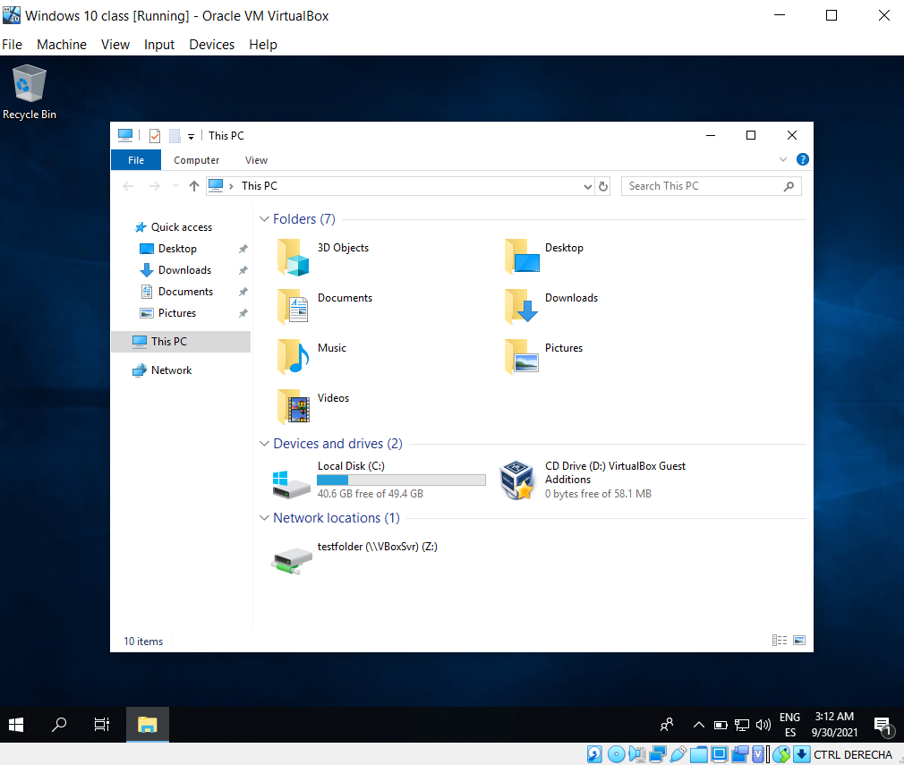

Next we will select devices within our virtual machine and we have to select “Insert GuesT Additions CD image..”.

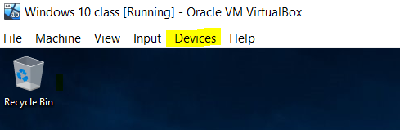

Finally we will back to the settings option and then we have to select Bidirectional from General, and this is done.

